*Final Delivery Specification*

**Distributed Systems Application**

***Team members:***

|  |  |  |  |
| --- | --- | --- | --- |
| *Clément Le Fay* | *Gustavo Braynner* | *Kyrill Cousson* | *Mani Safa* |

***Date: 10/06/2015***

Table of Contents

Introduction 3

The Application 4

State Diagram 4

Use-cases: 5

1) LOG IN 5

2) SEND PUBLIC MESSAGE 5

3) SELECT USER 6

4) SEND PRIVATE MESSAGE 6

5) GO TO CHATROOM 7

6) GO TO LIST OF PRIVATE CONVERSATIONS 7

7) EXIT APPLICATION 7

Deliverables 8

Hybrid Application 8

Peer-to-Peer Application 9

Test Plan/Report 9

User Manual 9

Presentation 10

1. Slide Presentation 10

2. Scripted Demonstration 10

3. Delivery of all the deliverables 10

4. Feedback Session 10

5. End of Presentation 10

# Introduction

The purpose of this document is to specify the deliverables of the third and last increment for the Distributed Systems Project. In the session “The Application”, the functionalities of the application will be specified defined. In the session “Deliverables”, all the deliverables and their format will be specified. In the session “Presentation”, a resume of the presentation will be described.

# The Application

## State Diagram

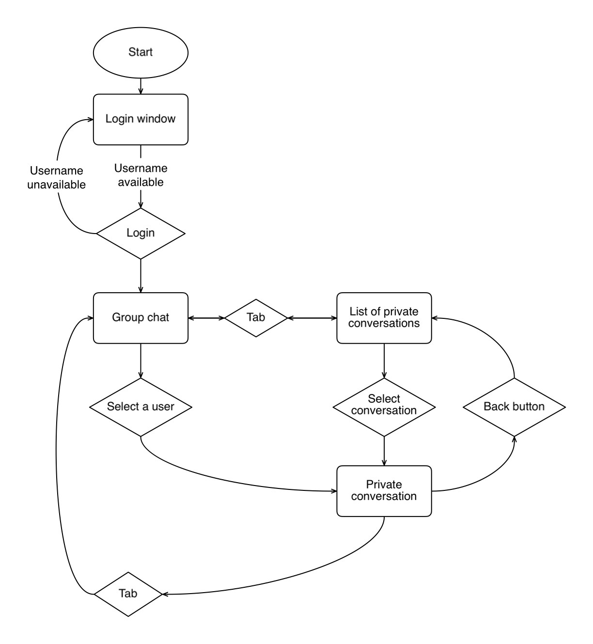

*State 1: Login Window;*

*State 2: Group Chat;*

*State 3: List of private conversations;*

*State 4: Private conversation.*

## Use-cases:

### LOG IN

**Goal:** Connect with other users

**Actor:** User

**Precondition:** State 1

**Post-condition:** State 2

**MSS:**

1. User inputs username;
2. User logs in;
3. System shows chatroom;

**EXT:**

3.1: System fails to connect with one of the user IP’s, a warning is given, and then the system shows the chatroom.

### SEND PUBLIC MESSAGE

**Goal:** Send a message on the chatroom to all other users

**Actor:** User

**Precondition:** State 2

**Post-condition:** State 2

**MSS:**

1. User writes a message;
2. User sends the message;
3. Message is displayed to all users online.

**EXT:**

2.1: C/S -> The server cannot be reached: Message is not broadcasted.

### SELECT USER

**Goal:** Start a private conversation with a user

**Actor:** User

**Precondition:** State 2, State 3

**Post-condition:** State 4

**MSS:**

**Case 1 (State 2):**

1. User selects a message in the chatroom to start a private conversation;
2. System displays a private conversation with the sender of the selected message.

**EXT:**

1.1: User selects a message of his own to start a private conversation, and nothing happens;

1.2: P2P -> User selects a message of an offline user: Nothing happens.

**Case 2 (State 3):**

1. User selects a user in the list of private conversations;
2. System displays a private conversation with the selected user.

**EXT:**

1.1: P2P -> User selects an offline user: Nothing happens.

### SEND PRIVATE MESSAGE

**Goal:** Send a message on a private conversation to the other user

**Actor:** User

**Precondition:** State 4

**Post-condition:** State 4

**MSS:**

1. User inputs a message;
2. User sends the message;
3. System displays message in the conversation of both users.

**EXT:**

1.1: P2P -> Other user is offline: User is unable to write and send message.

### GO TO CHATROOM

**Goal:** Show Chatroom

**Actors:** User

**Precondition:** State 3, State 4

**Post-condition:** State 2

**MSS:**

1. User chooses to go to the chatroom;
2. System displays chatroom.

### GO TO LIST OF PRIVATE CONVERSATIONS

**Goal:** Show list of private conversations

**Actor:** User

**Pre-Condition:** State 2, State 4

**Post Condition:** State 3

**MSS:**

**Case 1 (State 2):**

1. User chooses to go to the private conversations;
2. System displays the list of private conversations.

**Case 2 (State 4):**

1. User goes back;
2. System displays the list of private conversations.

### EXIT APPLICATION

**Goal:** Closing the app

**Actors:** User

**Precondition:** Any state

**Post-condition:** App is closed

**MSS:**

1. User clicks the “X” (exit) button;
2. The system closes the app.

# Deliverables

## Hybrid Application

The first of two versions of the application. When logging in, the users connect to the server. After connected, any public message sent will be given to the server, which will broadcast it to all online users. Users can connect with other users using the help of the server to start a peer-to-peer connection, which can be used for a private conversation. This deliverable includes the zipped projects, and a release version of both server and client.

**Must:**

* The server is hosted in another network than the users;
* The client and server are both failsafe (exception treatments, disconnection security, etc.);
* The private communication between users is exclusively done by a peer-to-peer connection;
* Users are in a different computer, but in the same subnet.
* Users are in a different network, but using a VPN connection to the same subnet.

## Peer-to-Peer Application

The second of two versions of the application. When logging in, the users connect to all the other online users. After connected, any public message sent will be directly broadcast to all online users. Users can also have a private conversation. This deliverable includes the zipped project, and a release version of the client.

**Must:**

* There is no server;
* The clients are failsafe (exception treatments, disconnection security, etc.);
* Users are in a different computer, but in the same subnet.
* Users are in a different network, but using a VPN connection to the same subnet.

## Test Plan/Report

Scripted testing of each of the functionalities in the specified conditions for both applications. This document will also include the results of the tests. This deliverable includes the word document containing the filled up test plan.

## User Manual

Two manuals with instructions on how to use each of the applications. This deliverable includes two word documents with each being one user manual.

# Presentation

## Slide Presentation

A slide presentation showing characteristics each application will be shown in the beginning of the presentation. It will cover the screens, the functionalities, environment restrictions (server and client possible locations on the web).

## Scripted Demonstration

A scripted demonstration testing all the features of each application, proving compatibility with the test report. This demonstration will be guided by a script, in the form of a sequential list of steps.

## Delivery of all the deliverables

All deliverables will be given to the client in a .zip file.

## Feedback Session

The client is expected to assume control of the meeting and give us his feedback on what was accomplished and on the final product.

## End of Presentation

The presentation is over.